The WordPress Blog Sites
Also known as the For Professionals Sites
(Information and Resource Sites managed by AGE)
Developed by the Author Work Group

Table of Contents
The WordPress Blog Sites 1
Table of Contents 1
Introduction 3
Getting Started 3
The WordPress Dashboard 3
New – Post or Media 5
Embedding: 5
Archiving 8
Adding Media 9
Managing Media 10

Introduction

The purpose of this document is to provide guidence on the use of the WordPress platform which is used to provide information and resources on the For Professionals Blog sites.
The ‘For Professionals’ Blog sites are a collection of sites developed and maintained by EOEA’s various program staff. The SIMS Support team should be considered a resource for using and understanding the this tool. Please feel free to send questions and concerns via the EAST ticketing system. You should select ‘UMass – Resource Blogs’ as the application when creating a ticket for support.
Below are some basic instructions on the most common features that site autors will use to create post. If there is anything that you are interested in that is not covered here please submit an EAST ticket.

Getting Started
To access the author tools for WordPress users will need to log into the UMass Single Sign-On portal. The url for the portal is https://login.microsoftonline.com and you should have already received your credentials and directions for registration of your account from UMass.
Once you sign in ou will see an icon for WordPress.

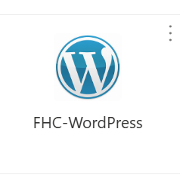

The WordPress Dashboard
Once you open WordPress the first screen you will be presented with is the Dashboard. From here you can both view and edit all sites and materials that you are assigned to. The Dashboard has three sections for operating. The navigation menu at the top, the sidebar menu and the viewing panel.
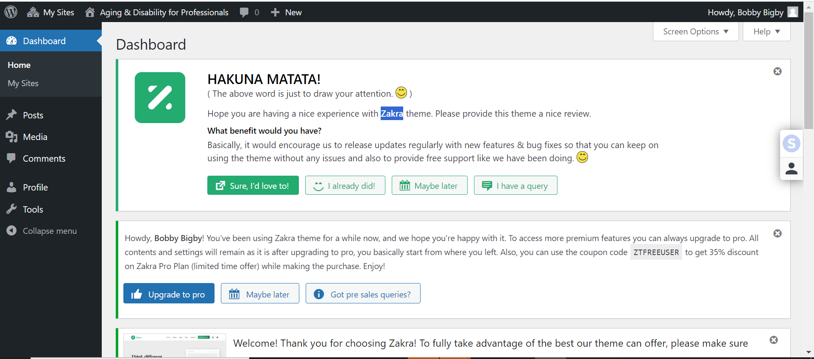
On the Navigation menu at the top, you will see the WordPress logo. This logo is a clickable button that will bring you to a WordPress Welcome screen. This screen contains information on WordPress itself. Most authors will not find this information directly relevant to their regular author activities.
Next to the logo is a menu titled ‘My Sites’. This menu will list any sites that you are allowed to view or edit. As you hover over list items you will be presented with your available options. If you are a true author of a site you will see options to add a post or manage comments.
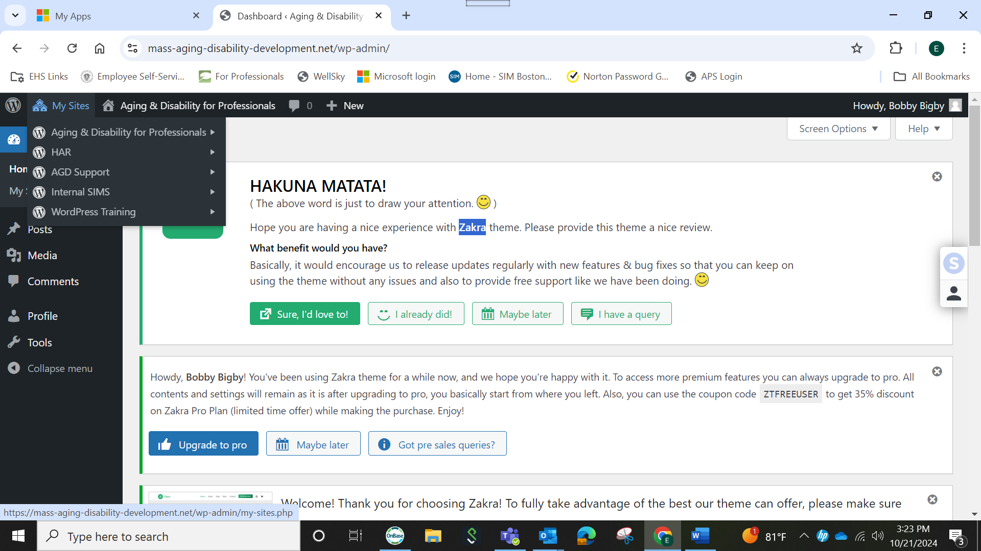
The third item on the Navigation bar is the title of the site you are currently viewing the Dashboard of. In the screenshot above the Dashboard being presented is for the main ‘AGE For Professionals’ blog site. Hovering over this item will present you with a link to visit the site. This is a view of the site as visitors would see it.

If you are an author for the site you will also see two other items. One for managing comments and another that will present you with choices for creating ‘New’ site content.
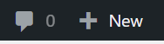

New – Post or Media
Creating a new post is very simple. Click “New – Post’ from the navigation bar. Or from the Sidebar menu selct ‘Post – New Post’. Once the new post screen is open you can enter a title and then enter the post information below it. There will usually be greyed out text where you can begin typing any text or adding media (files uploaded /to WordPress).
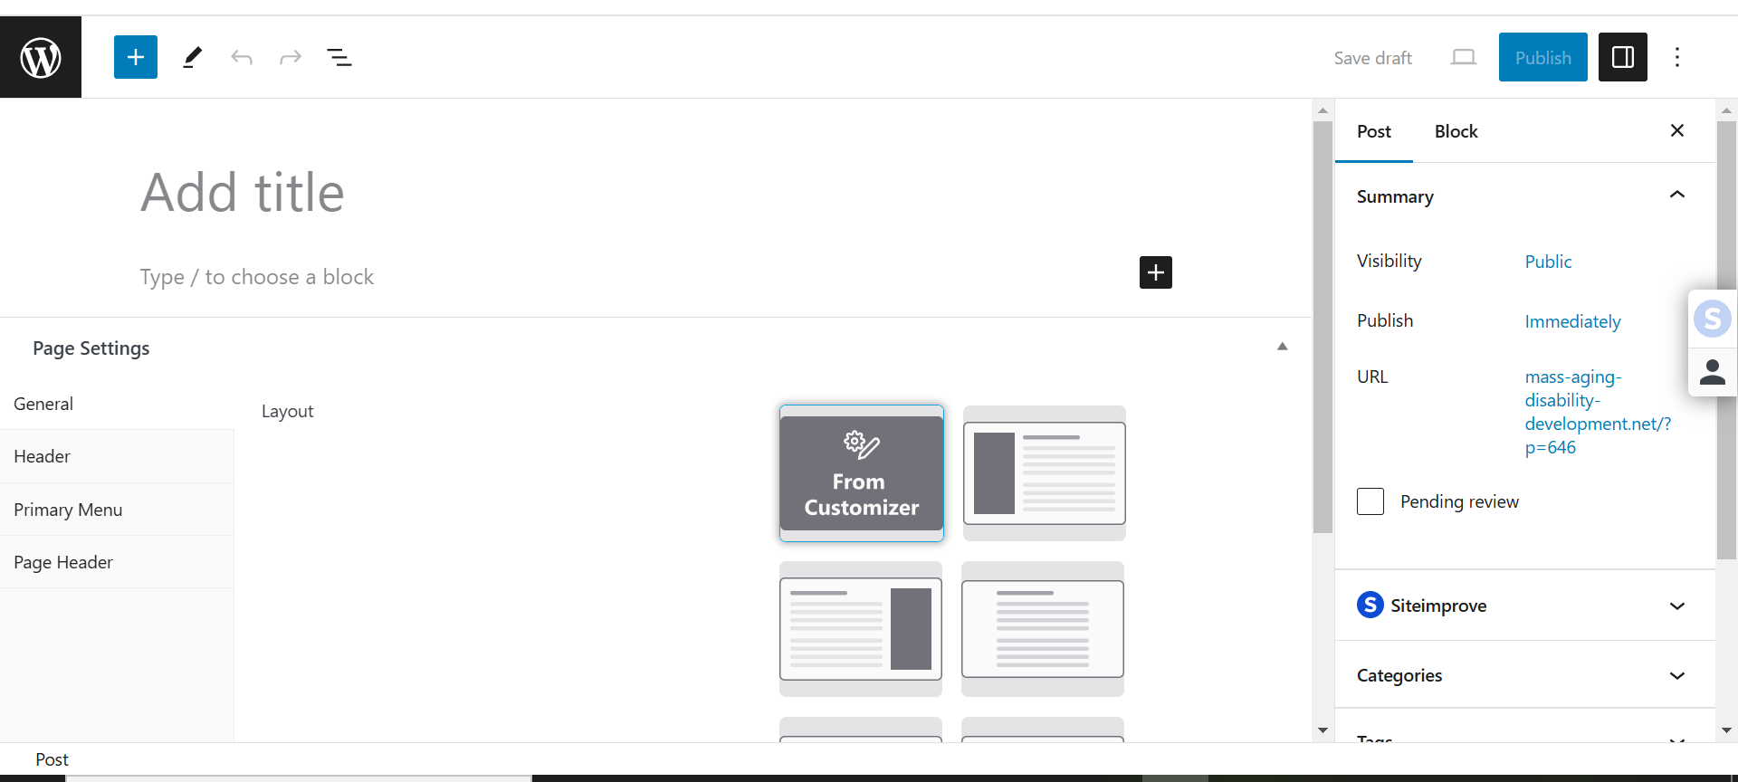
Heading: Will add a text block with larger text size to act as a divide between sections
Entering Text: You can begin entering text and any media links or images. Entering text is as simple as typing in the provided space. To insert a file you can type “/” followed by one of these commands:
- File: Inserts a link that site visitors can select to open or download files
- Image: will open a dialogue box where you can upload a new image or select a previously uploaded image from the media library.
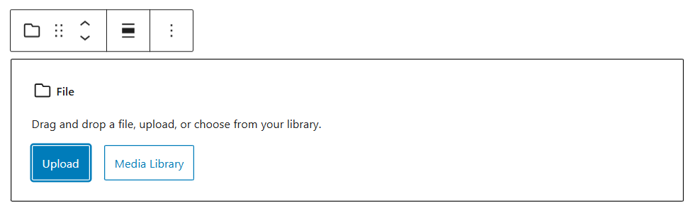
Comments: There are three layouts for the comments filed available. You will need to select the layout that you prefer. They all perform the same way.

Embedding:
Embedding in website design/development is a process that allows authors to add content to a site page/post that comes from another site. Using this method has the benefit of displaying the content even if it is modified.
To embed Google calendars, YouTube video and/or other items. We are using the block command 'Custom HTML'. This block is a simple text box where you can insert the html code provided by the video or calendar host site.
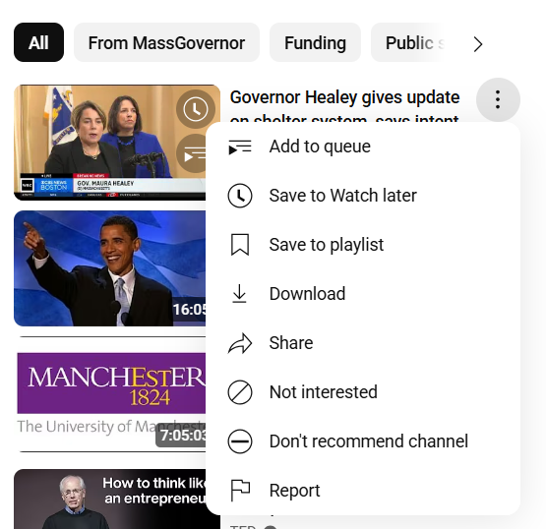
For YouTube video code: you should access the 'Share' feature for the video. This can be done by selecting the three dots that are present next to each video on the YouTube preview pages/ video list.

If you open a YouTube video you can also select the 'Share' feature.
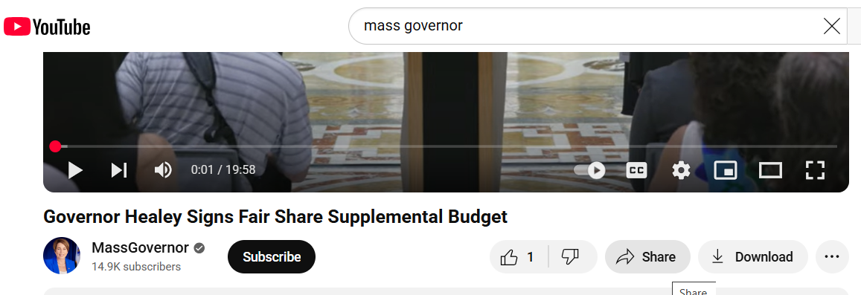
Once you select 'Share' an option for 'Embed' should be available. Select 'Embed' and a small pop up window should display a box with code text for you to highlight and copy. There is a ‘copy’ button that will highlight and copy text for you.
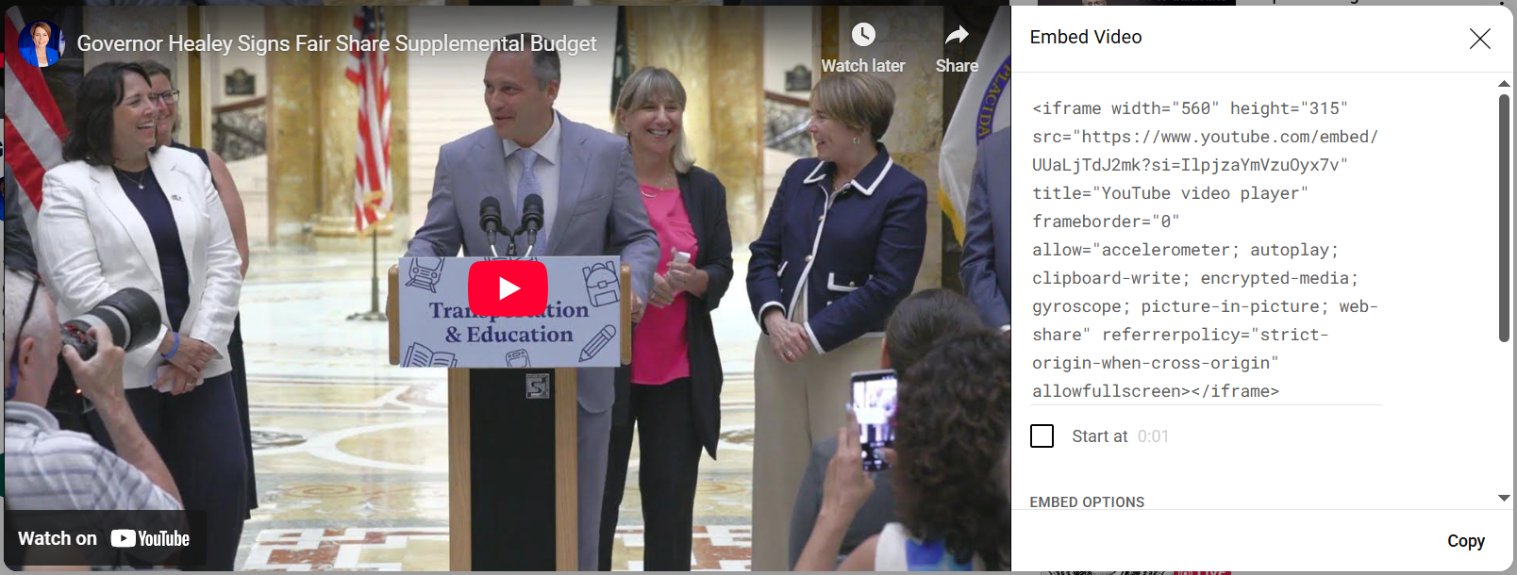
Once you have the code you can go to the post or create the new post for the video. In the text area type '/custom HTML' and paste the code into the provided box.
To view the video select 'Preview' from the block menu. You can go back to view/modify/replace the code by going back to the block menu and select 'HTML'.
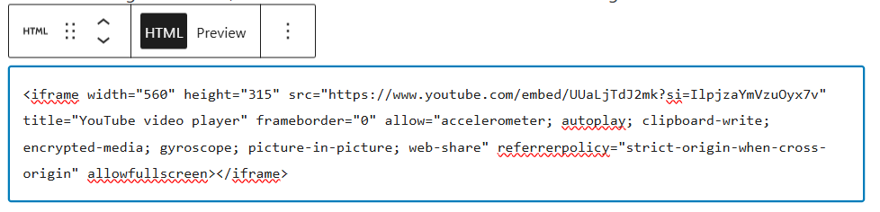
Video size: The size of the video display can be modified through the HTML code. However, it should be noted that modifying html code can have unintended consequences. It is always important to keep a copy of the original code. Once you are certain you can restore the code an author can attempt to modify the portion of the code that indicates size. (iframe width="450" height="200"). Adjusting and then previewing the video display will allow the author to confirm the playback appearance.
Video embedding alternative: When it comes to embedding video there is another method of embedding. You can use the block “/embed” instead of using the “/custom html”. To use this method you will need to use the first steps from the previously described method. That means locating the video you want to embed. Then select the three dots where you can select ‘Share’. This will produce a window that contains a URL link. You can copy and paste this link into the field the “/embed” block presents. This method is a little simpler than the “Custom HTML” method but limits the ability to adjust the size of the video display on the post/page.

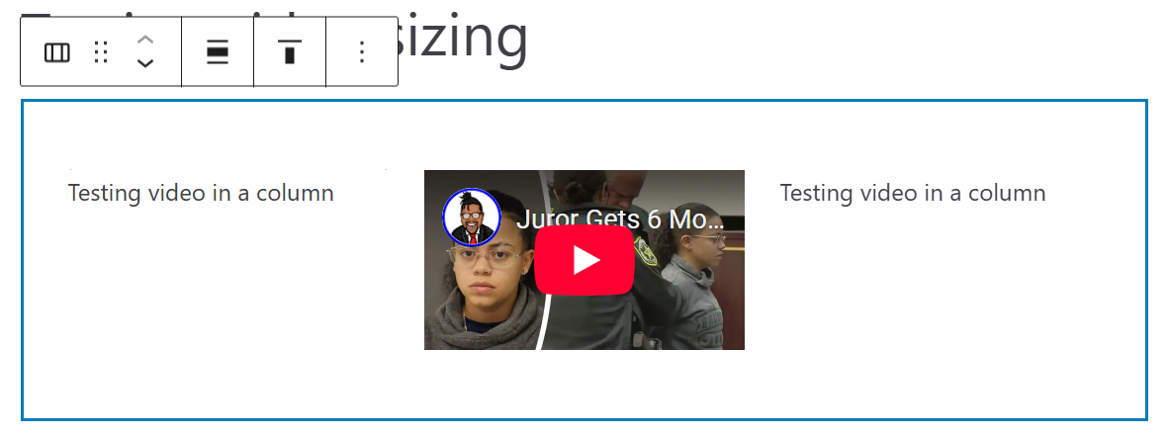

In order to reduce the size when using the “/embed” method authors would need to add the block to a column cell. (as seen above) You can add a set of columns by adding the “/columns” block to your page/post. Once the columns are in place you can add the “/embed’ or “/Custom HTML” block to any cell of the column that fits the authors design.
Once you have added all text and other items you can select the ‘Publish’ button in the top right section of the screen.
Note: You can save a post in a draft status. This will allow you to continue working on a post without publishing it immediately.

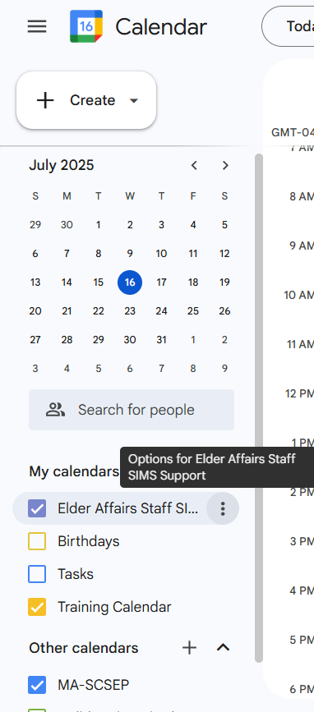
For Google Calendar: To share a Google Calendar through a post you will need to access the required code. Open and view your calendar. On the left side of the calendar is usually a column that displays a mini calendar and a list of ‘My Calendars’ you can choose to view. Next to the name of the calendar you want to share will be three dots. Click and select ‘Settings and Sharing’.
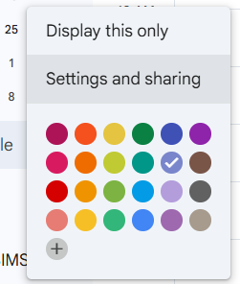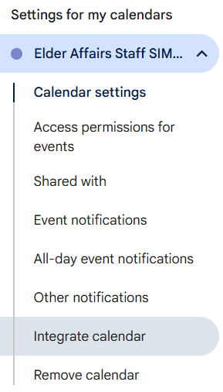
Once you have opened the ‘Settings’ page there will be a panel on the left side of the screen. You should find a listing titled ‘Integrate calendar’. Selecting this will cause the screen to jump to the correct section. Here you will find a box with code that is labeled ‘Embed code’. Highlight and copy this code. Then return to the post or create the new post for the video. In the text area type '/custom HTML' and paste the code into the provided box.
To view the calendar select 'Preview' from the block menu. You can go back to view/modify/replace the code by going back to the block menu and select 'HTML'.
Once you have added all text and other items you can select the ‘Publish’ button in the top right section of the screen.
Note: You can save a post in a draft status. This will allow you to continue working on a post without publishing it immediately.

Archiving
WordPress includes a feature for Archiving. By marking a post/page as ‘Archived’ the content will no longer be available to visitors. However, it will leave the content available to authors through the WordPress Dashboard.
To mark a post or page as archived you should locate the post or page on the appropriate site dashboard list. Once you have located the post/page you can hover over the title to find the link to perform a ‘Quick Edit’.

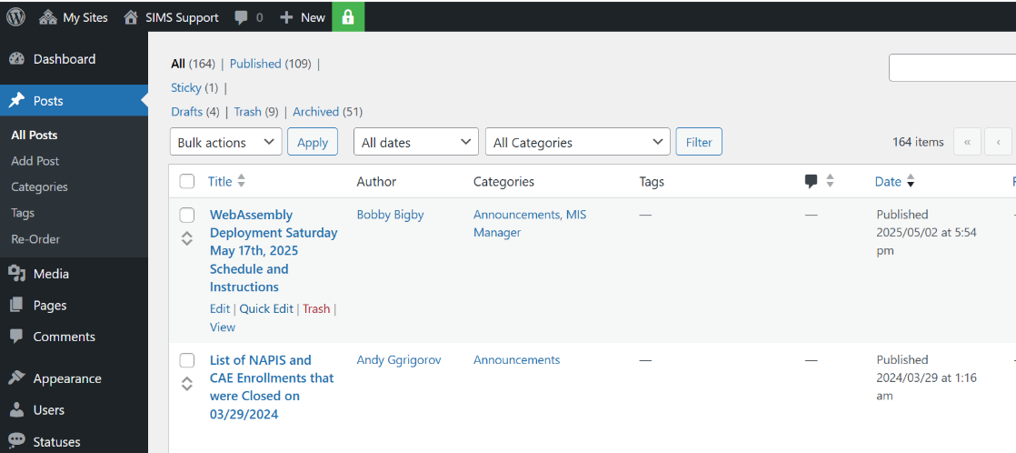

Once you click on the ‘Quick Edit’ link the menu will display below the title. On the menu is a selection field for the ‘Status’ of the post/page. From the drop-down list select ‘Archive’ to remove the post/page from site visitors. Once you have selected the new status you will need to click the ‘Update’ button to save the change.

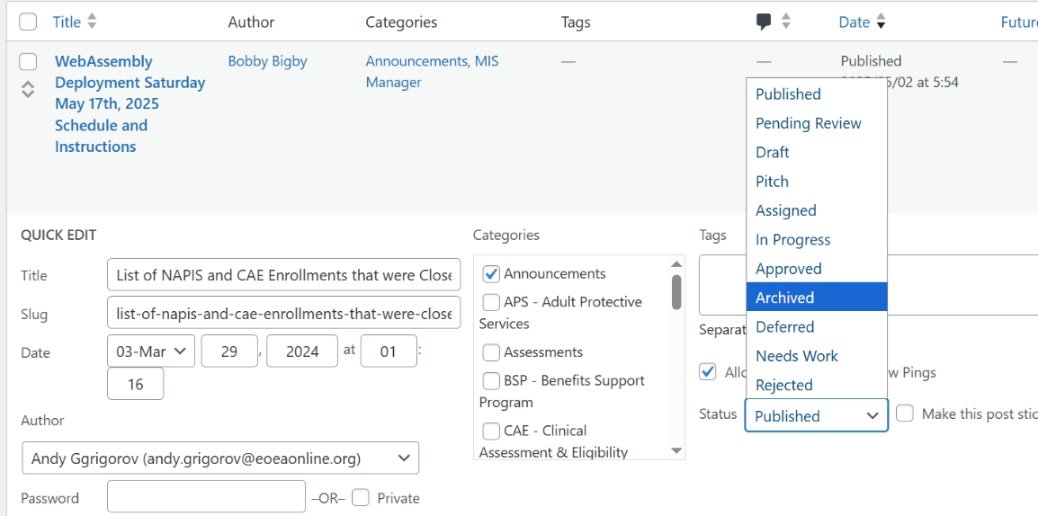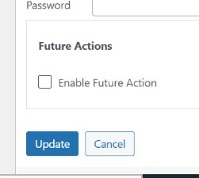
You will see a marker next to the post/page title on the dashboard list. Any post with this mark is available to authors through the dashboard but not to visitors on the site.
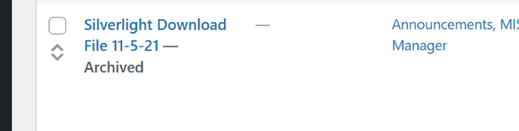

Adding Media
In WordPress all uploaded items are referred to as media. This includes Word documents, Excel spreadsheets and PowerPoint presentations. There are multiple ways of adding files to a post. One method is to upload your files to the library before opening and adding the item.
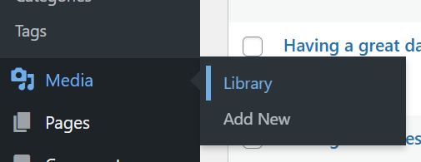
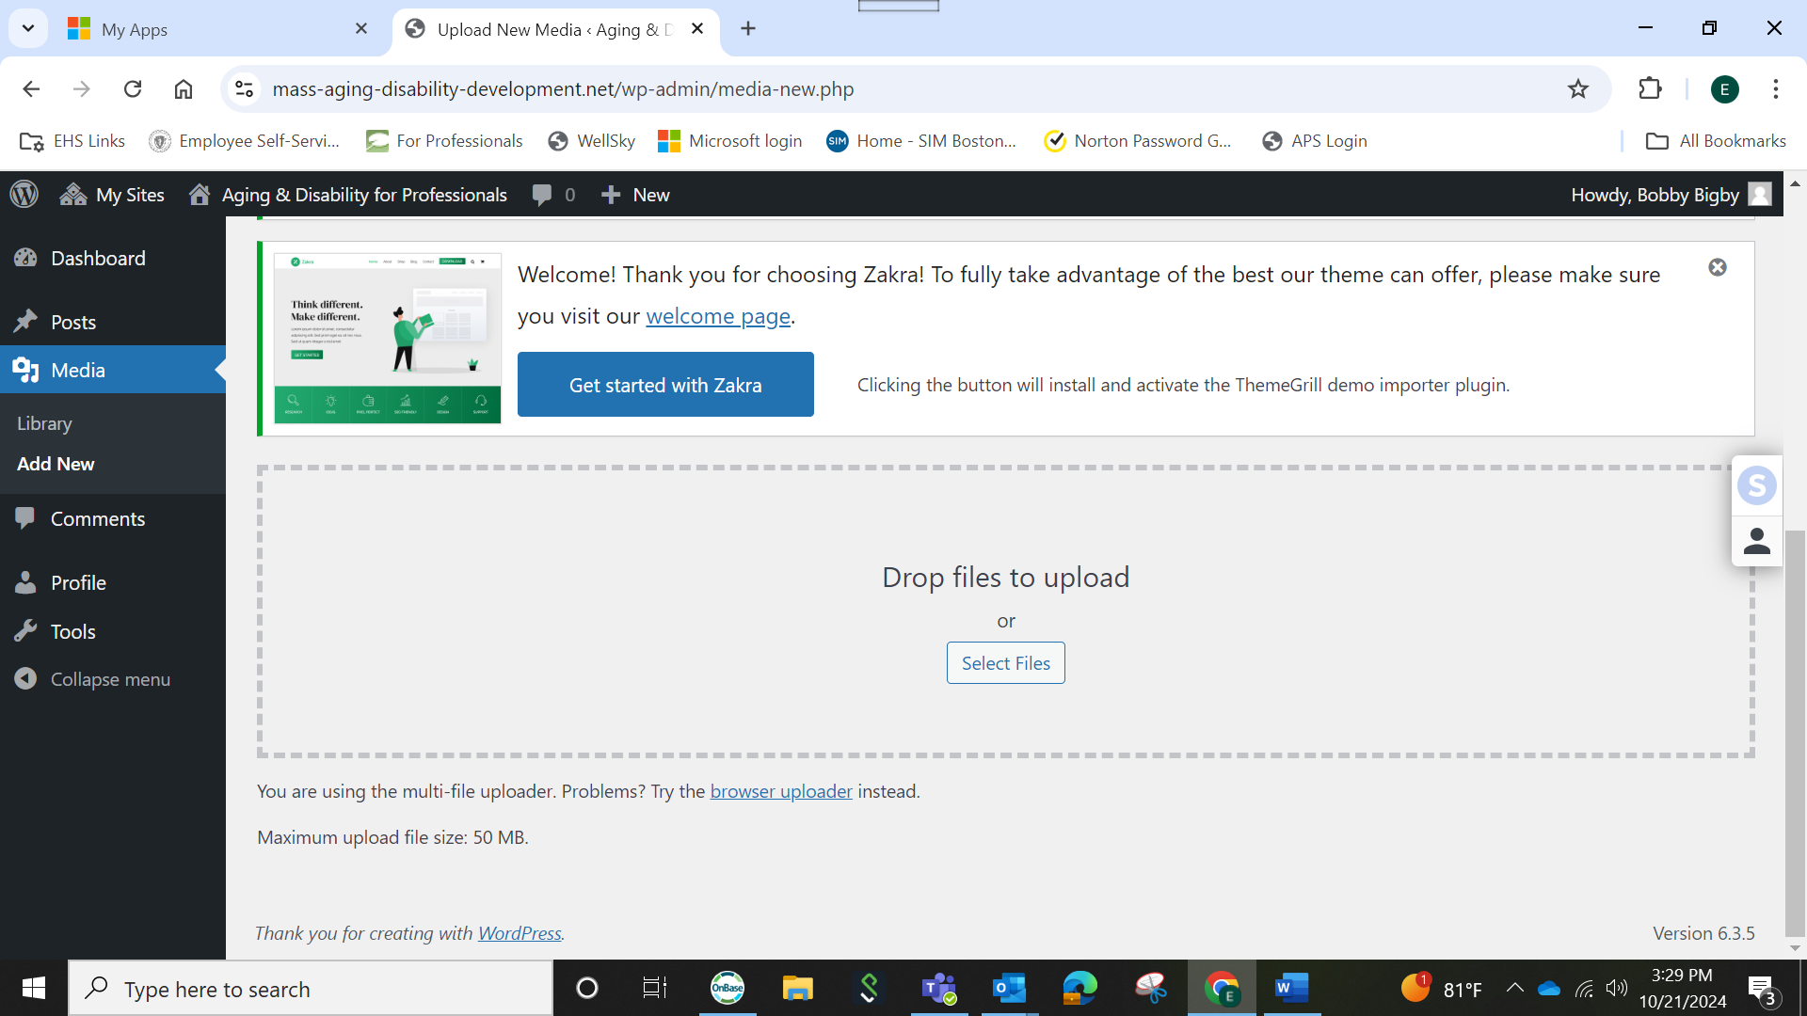
Files can be uploaded by dragging files from a ‘File Manger’ window or use the ‘Select File’ button to open the usual file selection window used when open files. Files should not exceed a file size of 50 MB.
Once you have uploaded the file you can add it to the post of your choice by typing “/file”

Managing Media
Open the ‘Media – Library’ then scroll down to see the list of files.
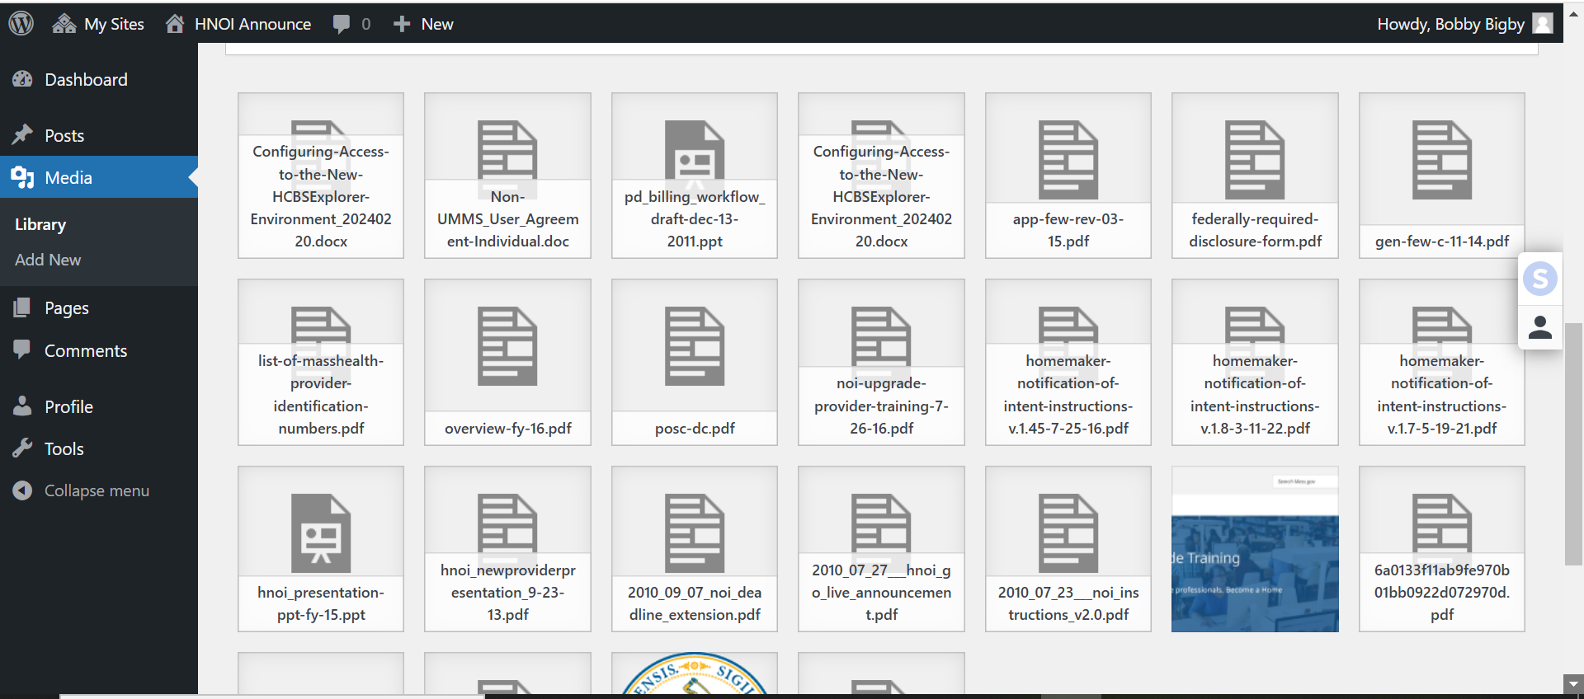
Select the file and a window will open where you will find a button to copy the files URL:

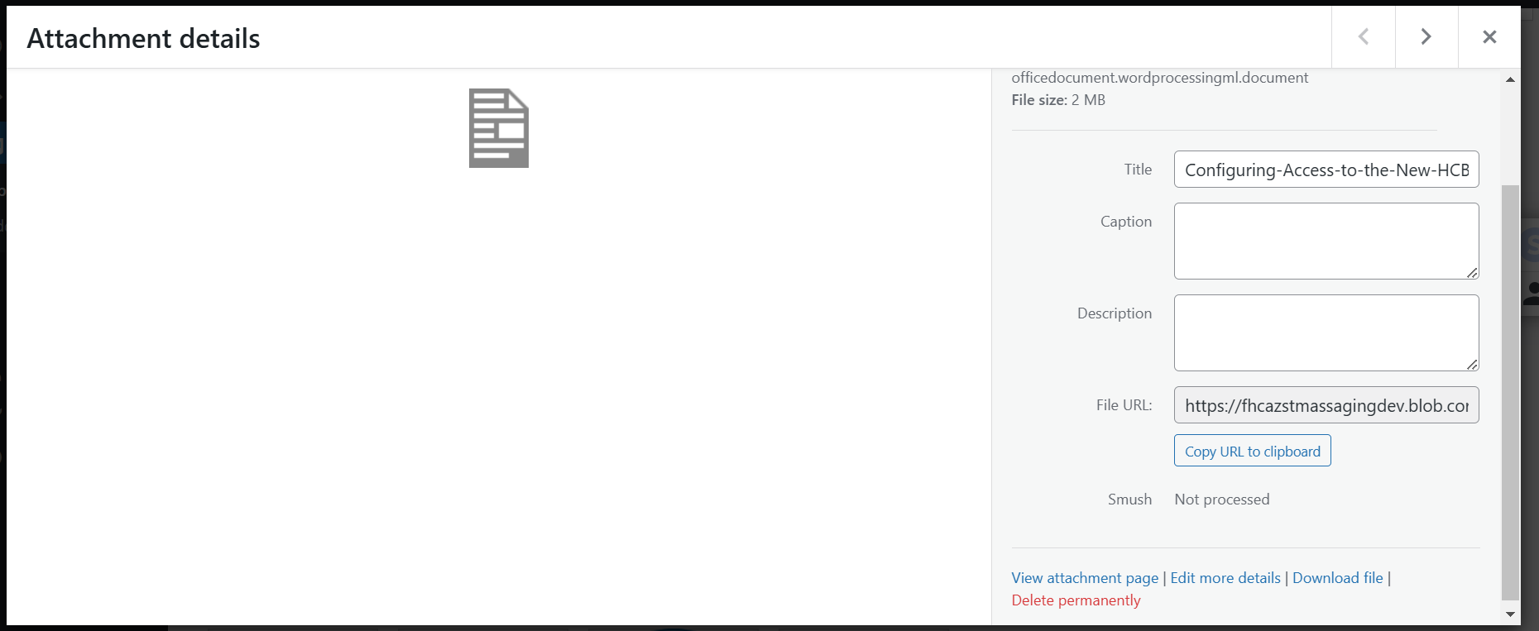

After closing this window either open the ‘All Post’ window (shown below) where you can open and edit a post or ‘Add New’ to open the new post window
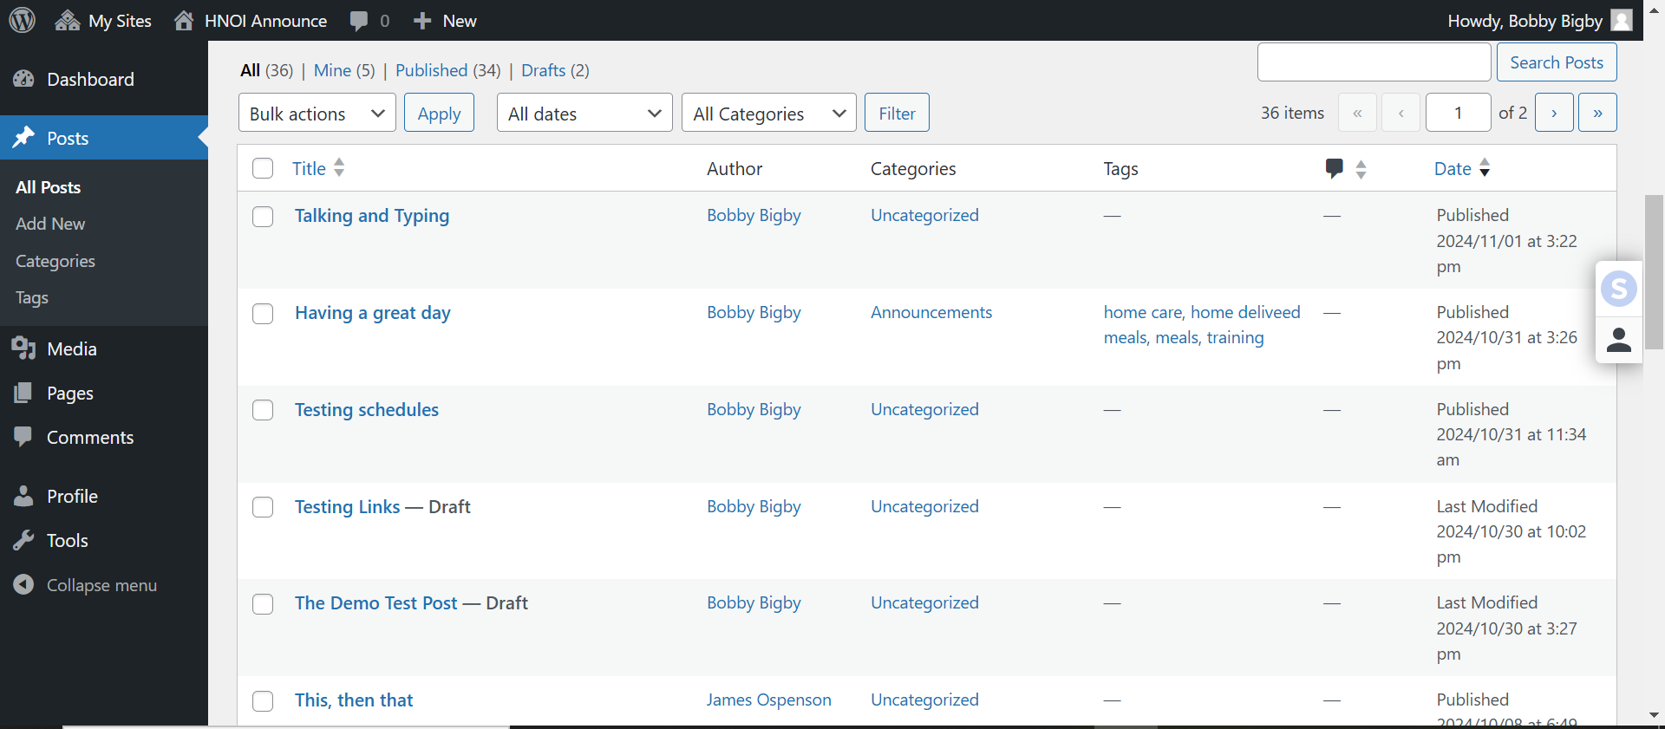
In the New or Edit Post screen type the text for the link. Then highlight the text to gain access to the floating menu.
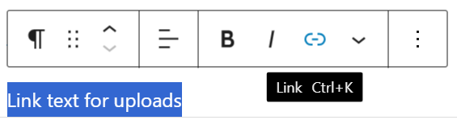
Select the link button to open a window where you can paste the file URL. Using the keyboard combination Ctrl+V will paste the URL. Hit ‘Enter’ on the keyboard to complete the link.
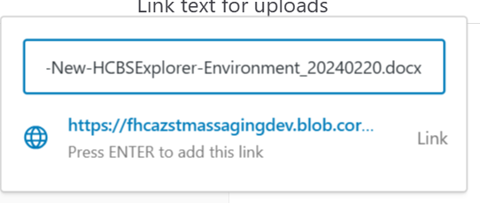
Issues and questions regarding WordPress should be submitted through EAST. If you are not sure about the EAST system please let me know. (bobby.bigby@mass.gov)

